## K2-1

### Words:

Elmo Big Bird

Cookie Monster Bert

Ernie Mr. Noodle

Dorothy Zoe

Abby Murray

### Sentences:

Elmo is my friend.

Big Bird is my friend.

Cookie Monster is my friend.

Bert is my friend.

Ernie is my friend.

## K2-2

### Words:

Friends play

Shake hands Play together

Hug Play baseball

read books

### Sentences:

We are good friends.

Friends shake hands.

Friends play together.

Friends hug.

Friends read books.

Friends play baseball.

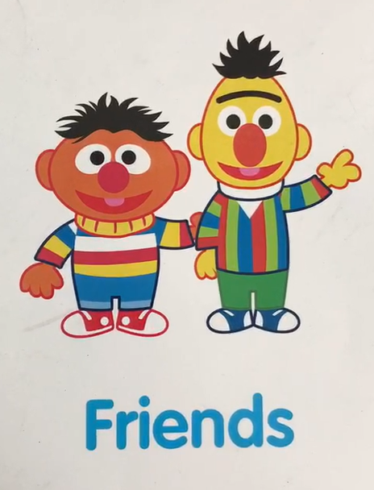 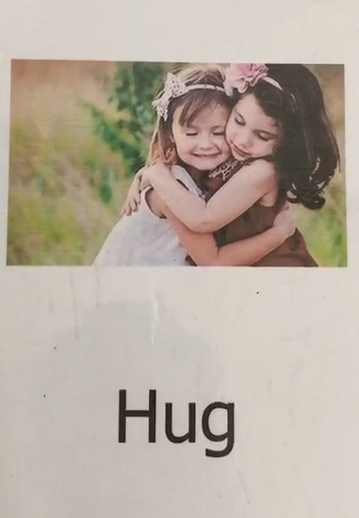

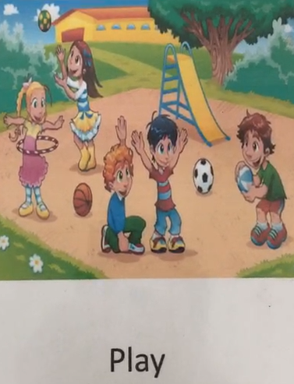 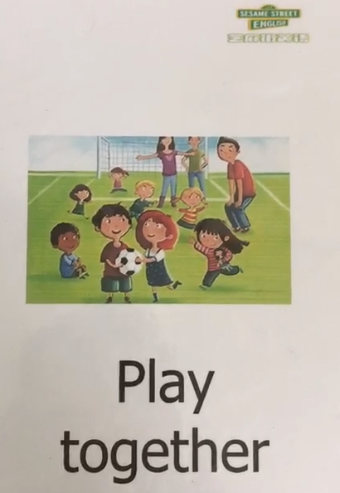

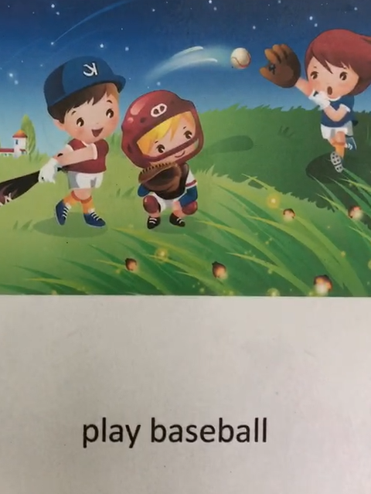 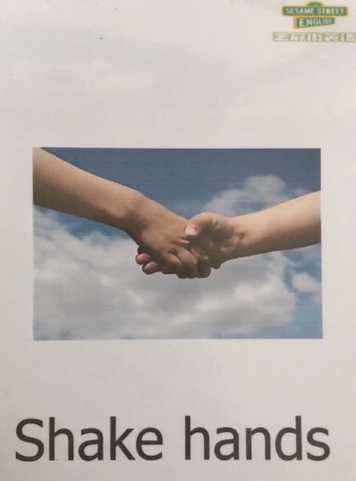

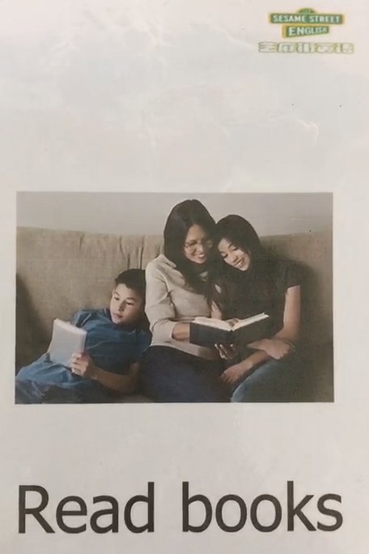

## K2-3

### Words:

Letter M/m

Uppercase M

Lowercase m

Letter M/m makes the sound /m/

milk

moon

monster

Monkey

### Sentences:

I drink milk.

Monkeys jump.

Monkeys swing.

Monkeys eat bananas.

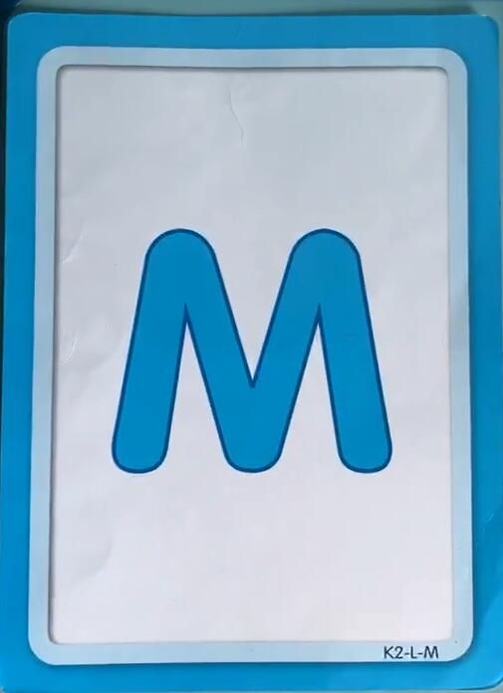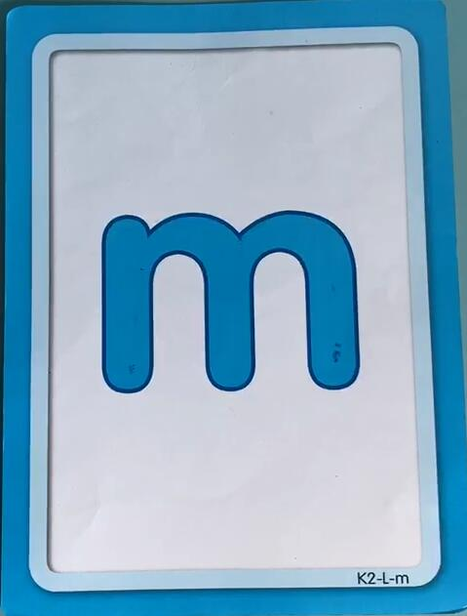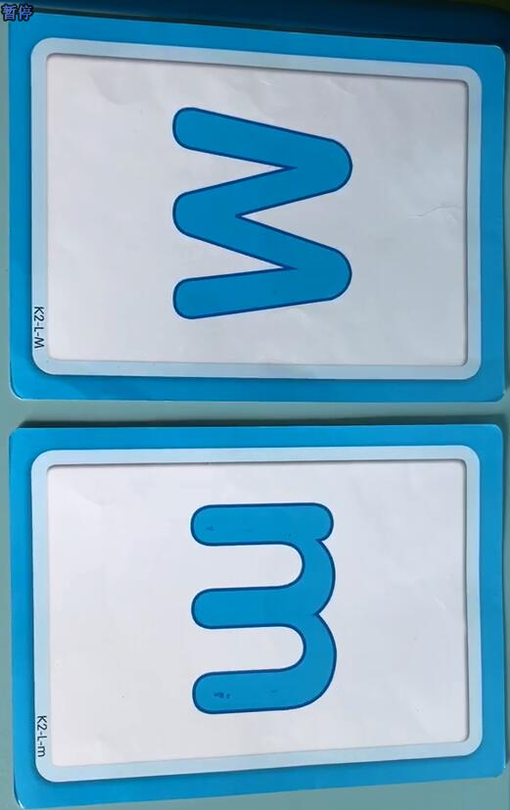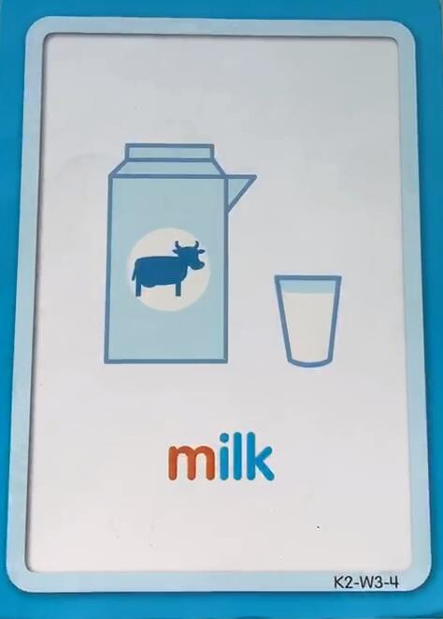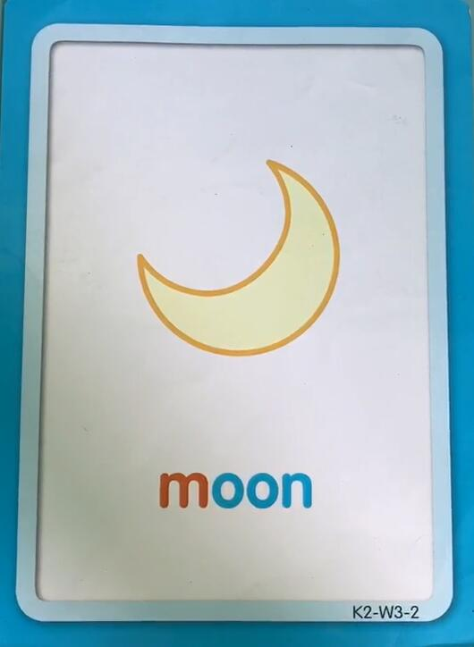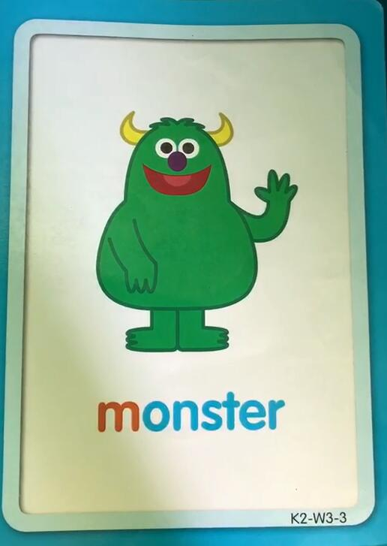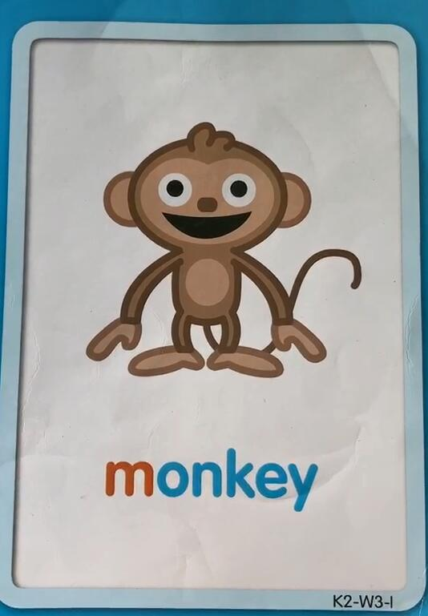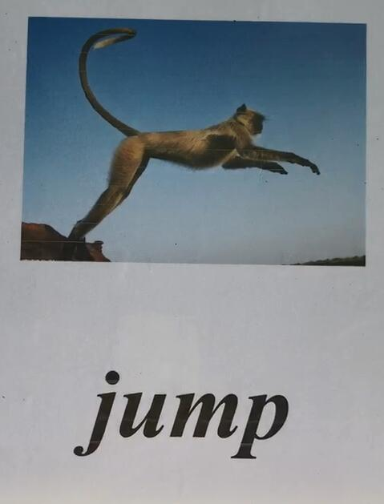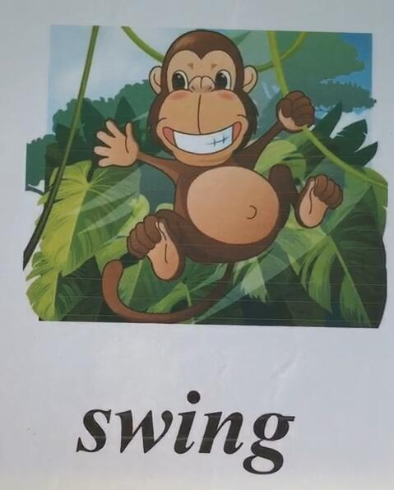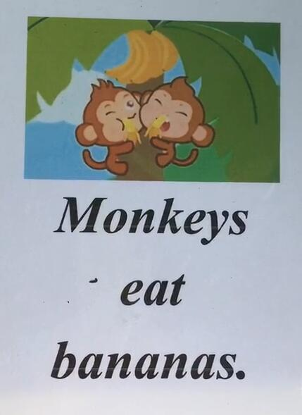

## K2-4

### Words:

Letter A/a

Uppercase A

Lowercase a

Letter A/a makes the sound /a/

apple

arrow

ant

animals

### Sentences:

Apples are red.

Apples are round.

Apples are yummy.

Arrow to the right.

Arrow to the left.

